BAŠKA OUTDOOR FESTIVAL 2026
9. – 11. listopada 2026 / October 9 – 11, 2026

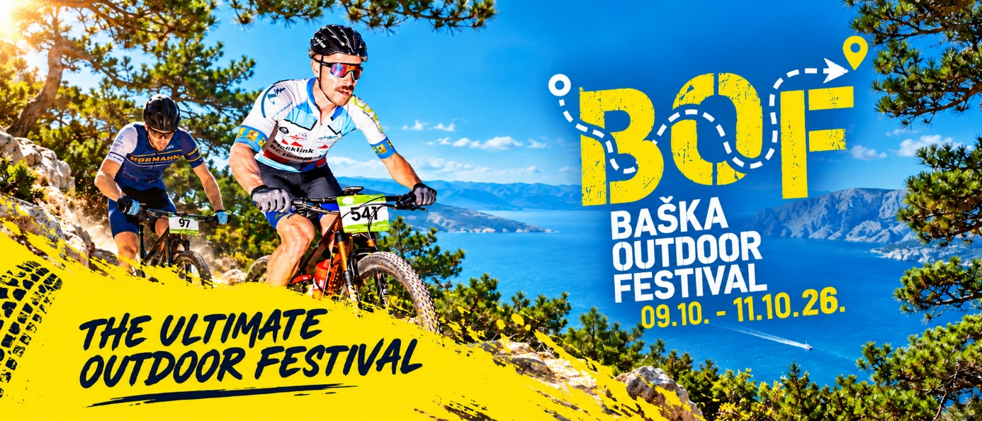

PETAK / FRIDAY – 9.10.2026.

ZIP & FLY
Zipline Edison
Prijevoj Treskavac / Treskavac Pass
10:00 – 16:00
Prijave & info / Registration & info: +385 98 626 061 | igor.adventureturs@gmail.com

FUN & OFF PROGRAM
Powerd by Porto Club Baška
20:00 – 03:00 INFINITY BAND CROATIA

Motivacijsko predavanje / Motivational Lecture
21:00
Sunny Baška Hotel by Valamar

SUBOTA / SATURDAY – 10.10.2026.

KRK 'N' ROLL MTB MARATHON – 10 IZDANJE !
Husqvarna Adria Bike Series
Sunny Baška Hotel by Valamar
3 staze / trails: 72 km / 48 km / 27 km
09:45
Start utrke za e-bike kategoriju / Race start for e-bike category
10:00
Start utrke za ostale kategorije / Race start for other categories
Prijave / Registration: https://www.adriabike.hr/events/krk-n-roll-2026-mtb-maraton/

KRK 'N' TRAIL
Trekking League
Šetnica ispred Porto Beach Cluba Baška / Promenade in front of Porto Beach Club Baška
3 staze / 3 trails:
Challenger 24 km / 700 m+
Active 14 km / 450 m+
Light 7 km / 300 m+
11:30
Start utrke za sve kategorije / Race start for all categories
Prijave / Registration: www.outdoor.hr/krk

TOUCH THE SKY
Anima Adventures
Portafortuna Penjalište / Portafortuna Climbing Area
Sportsko penjanje / Sport climbing
09:00 – 16:00
* start ispred / start in front of Restaurant Mošuna
Prijave / Registration: https://forms.gle/T4vJeb1jzNmsWakw8

ZIP & FLY
Zipline Edison
Prijevoj Treskavac / Treskavac Pass
10:00 – 16:00

FAMILY OUTDOOR CORNER
Park pored Sunny Baška Residence by Valamar / Park next to Sunny Baška Residence by Valamar
09:00 – 10:00
Time for yoga (Barbara Lipovšćak)
10:00 – 12:00
Mala škola MTB-a / MTB Kids Training (BBK Team Rodeo)
10:00 – 15:00
Slackline & dječje igre / Slackline & kids’ games (Anima Adventures)
10:00 – 15:00
Sportsko penjanje na umjetnoj stijeni / Artificial rock climbing (Anima Adventures)

FUN & OFF PROGRAM
Powerd by Porto Club Baška
14:00 – 03:00 DJ & Live concert

NEDJELJA / SUNDAY – 11.10.2026.

TOUCH THE SKY
Anima Adventures
Belove stene Penjalište / Belove Stene Climbing Area
Sportsko penjanje / Sport climbing
09:30 – 16:00
* start ispred / start in front of Restaurant Mošuna
Prijave / Registration: https://forms.gle/T4vJeb1jzNmsWakw8

ROCKY HILL HIKE TOUR
Anakin Adventures
Baška – Zakam – Diviška – Hlam – Mjesečev plato – Baška
Heritage Hotel Forza (okupljanje / gathering point)
Total 14,5 km, USP. / ASC. 450 m
09:30 – 14:00
Prijave / Registration: https://forms.gle/GYFUAgYXMCW42J816

ZIP & FLY
Zipline Edison
Prijevoj Treskavac / Treskavac Pass
10:00 – 16:00

FAMILY OUTDOOR CORNER
Park pored Sunny Baška Residence by Valamar / Park next to Sunny Baška Residence by Valamar
09:00 – 10:00
Time for yoga (Barbara Lipovšćak)
10:00 – 15:00
Slackline & dječje igre / Slackline & kids’ games (Anima Adventures)
10:00 – 15:00
Sportsko penjanje na umjetnoj stijeni / Artificial climbing wall (Anima Adventures)
11:00 – 12:00
FAST & CURIOUS
Dječja trkačka utrka / Kids Run Race
Prijave / Registration: https://forms.gle/f8edunmjWqe47M8p9

INFO
Turistička zajednica općine Baška / Baška Tourist Board
www.visitbaska.hr
+385 51 856 817
info@visitbaska.hr

